TUTORIAL – 11
Python Automation Testing using Selenium WebDriver
Project Name | Python Automation Testing
Module Name | Navigation, Forms, Links and Multi-Page Workflow
Test Case ID | TC011
Tester Name | Vidhi patel
Application Under Test | SauceDemo Web Application (https://www.saucedemo.com/)
Tools Used | Python, Selenium WebDriver, Google Chrome
SDLC Model | Agile

Test Scenarios with Screenshots

Scenario NAV01: Open website
Scenario ID | NAV01
Scenario | Open website
Test Steps | 1. Run the Python script.  2. Launch the browser.  3. Navigate to the website.
Expected Result | Website opens successfully.
Actual Result | Website opens successfully.
Status | Pass
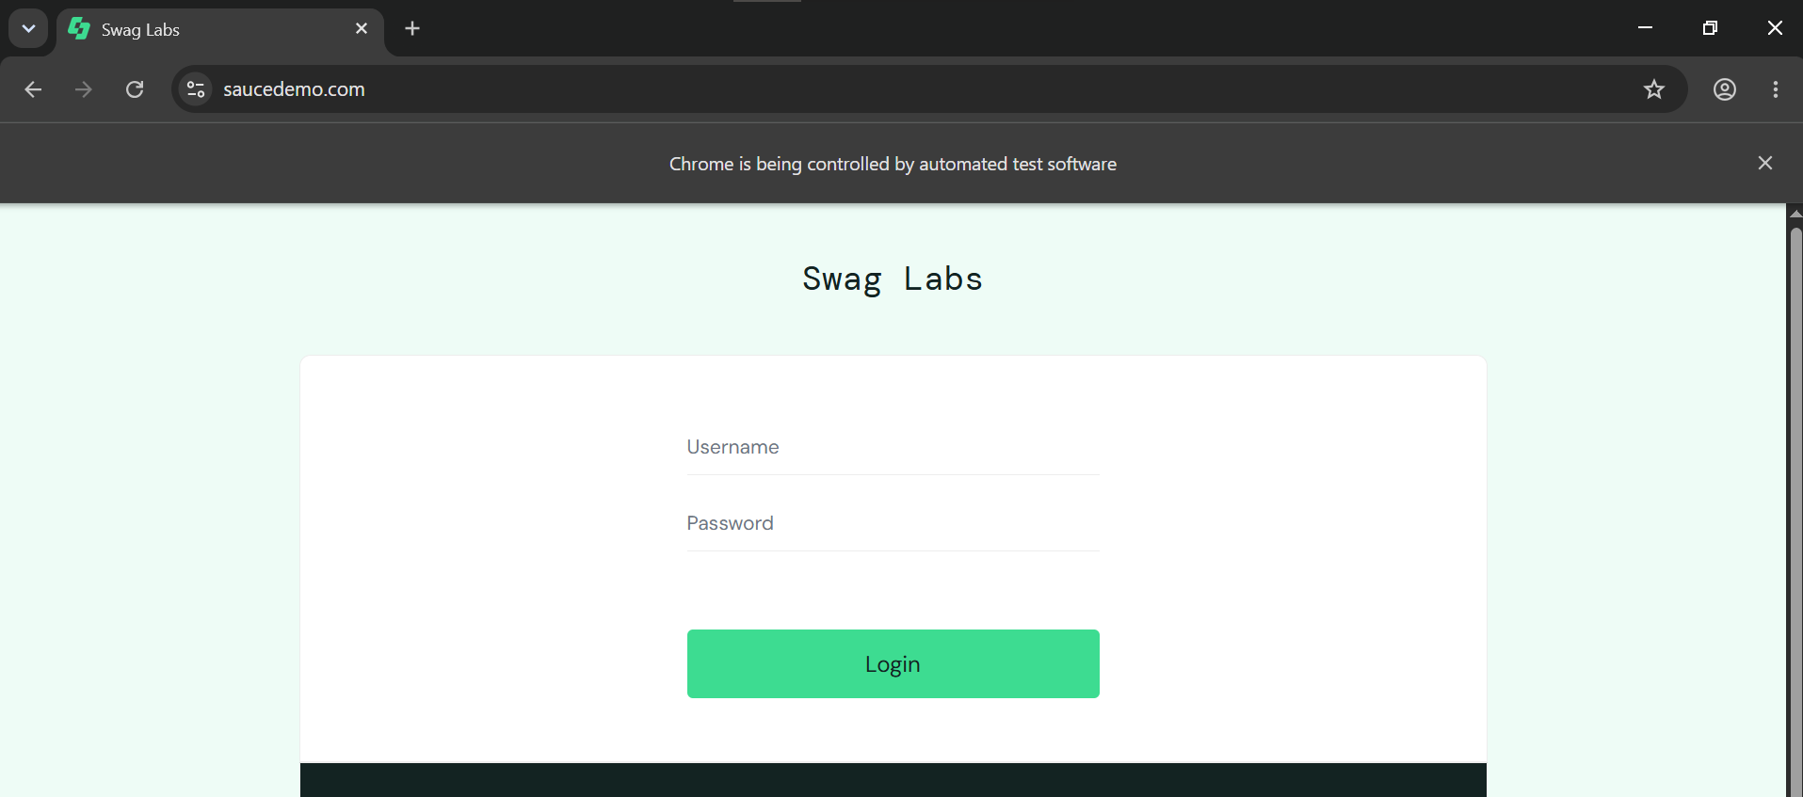
Figure 1: SauceDemo login page opened by Selenium

Scenario NAV02: Open Products page
Scenario ID | NAV02
Scenario | Open Products page
Test Steps | 1. Log in with valid credentials.  2. Inspect the inventory page.  3. Verify product names, prices and images.
Expected Result | Products page is displayed after login.
Actual Result | Products page is displayed after login.
Status | Pass
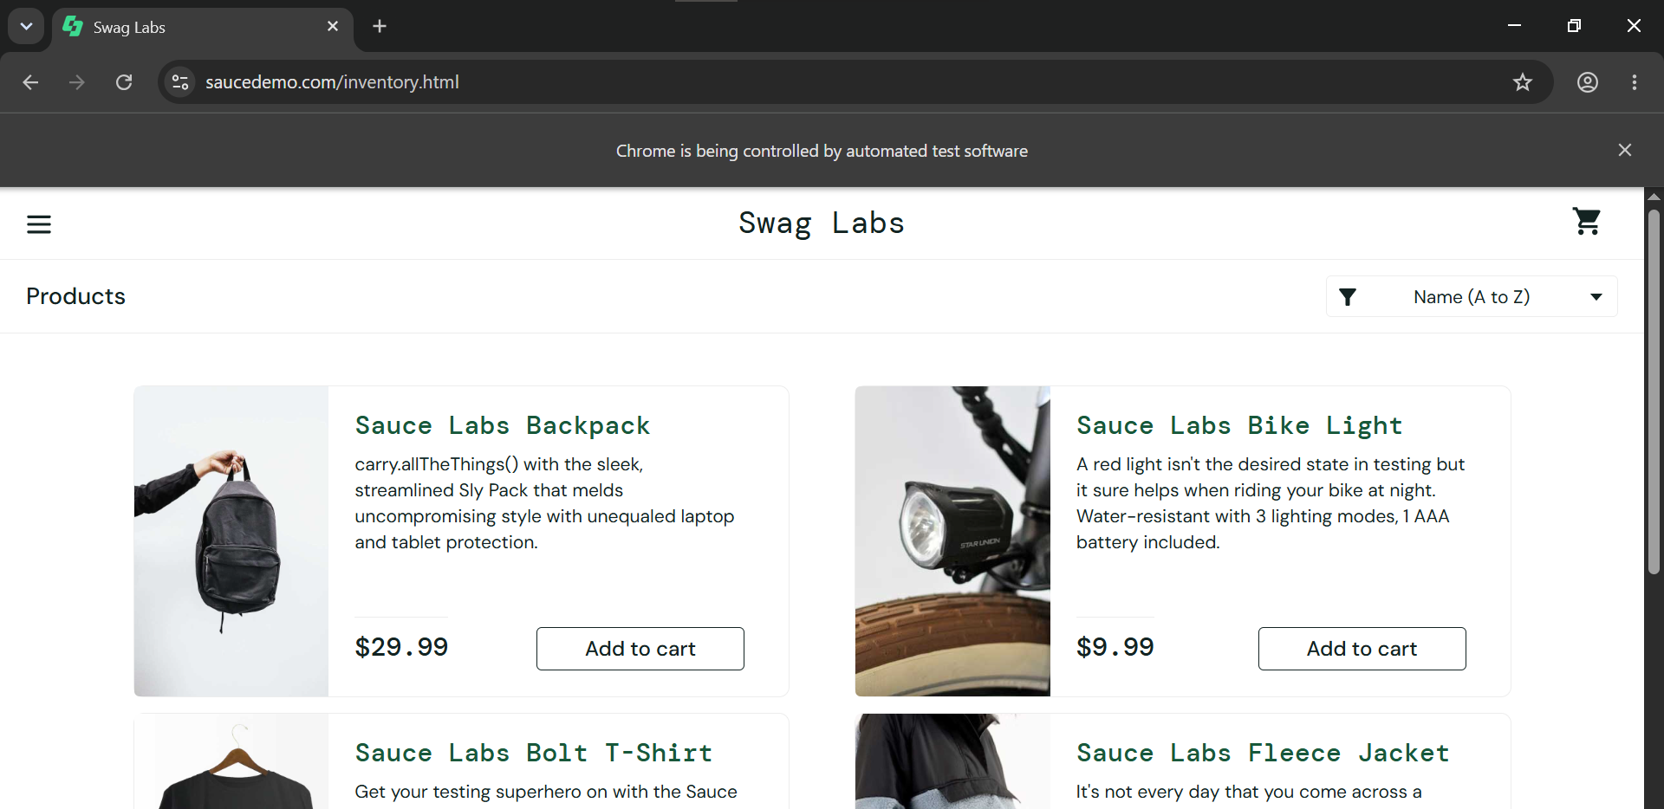
Figure 2: Products (inventory) page after successful login

Scenario NAV03: Add to cart
Scenario ID | NAV03
Scenario | Add to cart
Test Steps | 1. Open a product.  2. Click Add to cart.  3. Handle any confirmation dialog if displayed.
Expected Result | Product is added to the cart.
Actual Result | Product is added to the cart.
Status | Pass
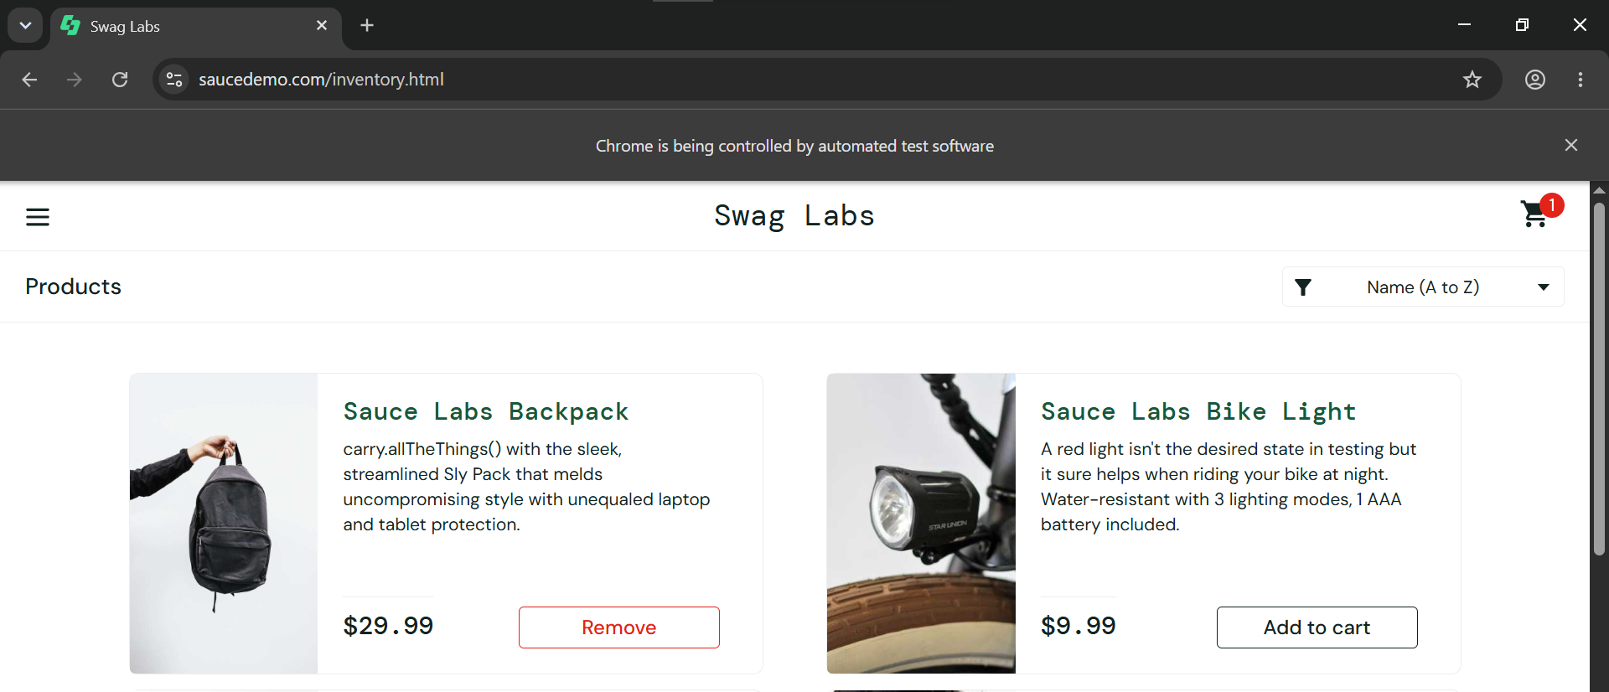
Figure 3: Product added to cart

Scenario NAV04: Open cart
Scenario ID | NAV04
Scenario | Open cart
Test Steps | 1. Add a product to the cart.  2. Navigate to the cart.  3. Verify the cart contents.
Expected Result | Cart page opens with the selected product.
Actual Result | Cart page opens with the selected product.
Status | Pass
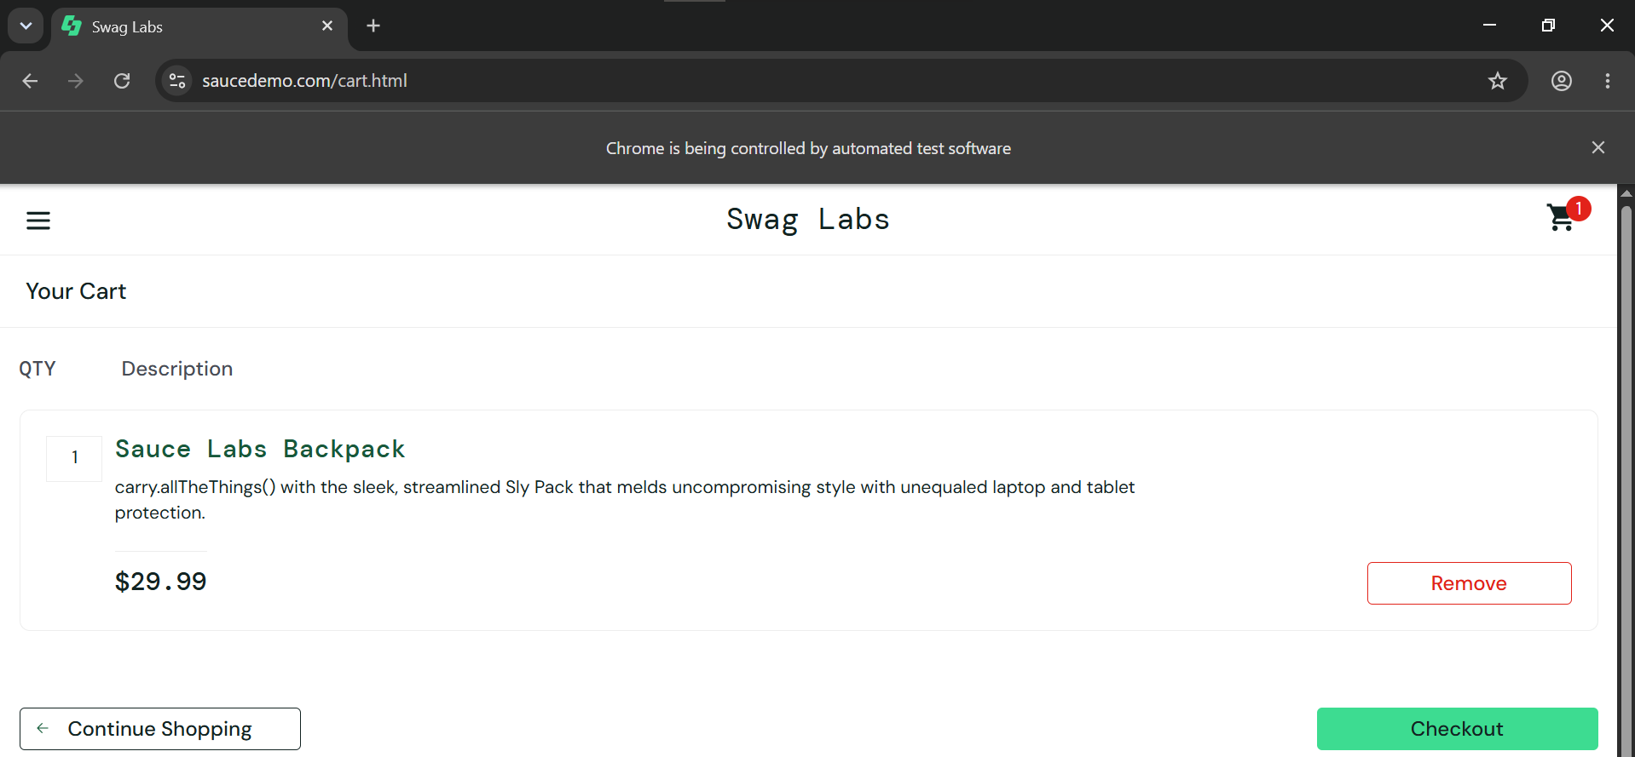
Figure 4: Cart page with the selected product

Scenario NAV05: Checkout page
Scenario ID | NAV05
Scenario | Checkout page
Test Steps | 1. Add a product to the cart.  2. Navigate to the cart.  3. Enter checkout information and continue.
Expected Result | Checkout data is accepted and next page opens.
Actual Result | Checkout data is accepted and next page opens.
Status | Pass
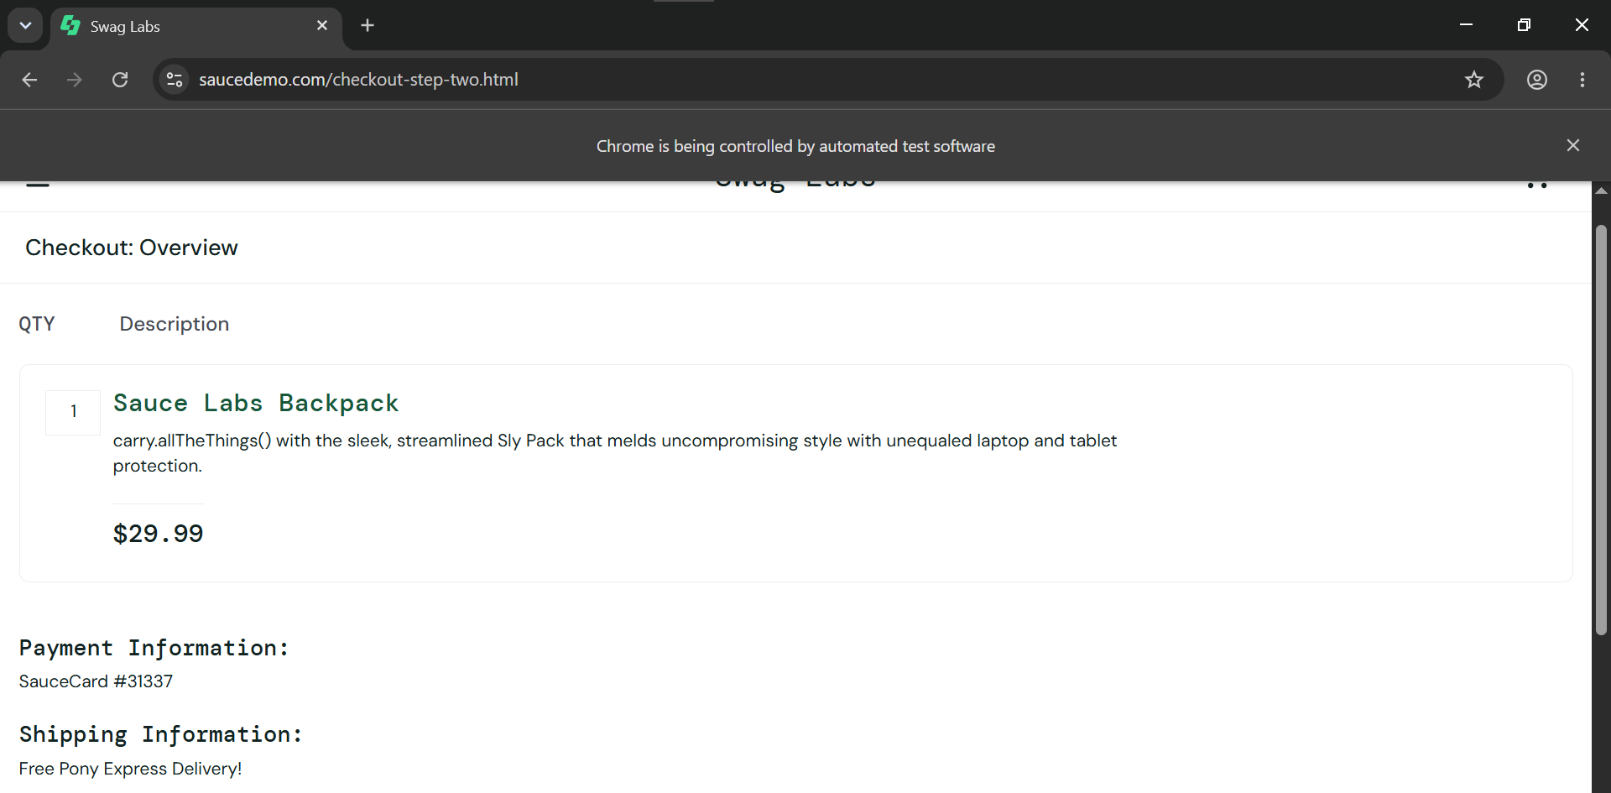
Figure 5: Checkout information form

Source Code
from selenium import webdriver
from selenium.webdriver.common.by import By
from selenium.webdriver.support.ui import WebDriverWait
from selenium.webdriver.support import expected_conditions as EC

driver = webdriver.Chrome()
driver.maximize_window()
wait = WebDriverWait(driver, 10)

try:
# 1. Open Website
driver.get("https://www.saucedemo.com/")
print("Website opened successfully")

# 2. Login
wait.until(
EC.visibility_of_element_located((By.ID, "user-name"))
).send_keys("standard_user")
driver.find_element(By.ID, "password").send_keys("secret_sauce")
driver.find_element(By.ID, "login-button").click()

# 3. Validate Products Page
wait.until(EC.url_contains("inventory"))
assert "inventory" in driver.current_url
print("Login Test: PASS")

# 4. Product Selection
wait.until(
EC.element_to_be_clickable(
(By.ID, "add-to-cart-sauce-labs-backpack")
)
).click()
print("Product Selection: PASS")

# 5. Open Cart
driver.find_element(By.CLASS_NAME, "shopping_cart_link").click()
assert "cart" in driver.current_url
print("Cart Navigation: PASS")

# 6. Checkout
driver.find_element(By.ID, "checkout").click()

# 7. Checkout Form
wait.until(
EC.visibility_of_element_located((By.ID, "first-name"))
).send_keys("Student")
driver.find_element(By.ID, "last-name").send_keys("Testing")
driver.find_element(By.ID, "postal-code").send_keys("380001")
driver.find_element(By.ID, "continue").click()

# 8. Validate Multi-page Workflow
wait.until(EC.url_contains("checkout-step-two"))
assert "checkout-step-two" in driver.current_url
print("Multi-Page Workflow: PASS")

# 9. Back and Forward
driver.back()
driver.forward()
print("Back/Forward Navigation: PASS")

finally:
driver.quit()
print("Tutorial 11 Completed Successfully")

Source Code Screenshots
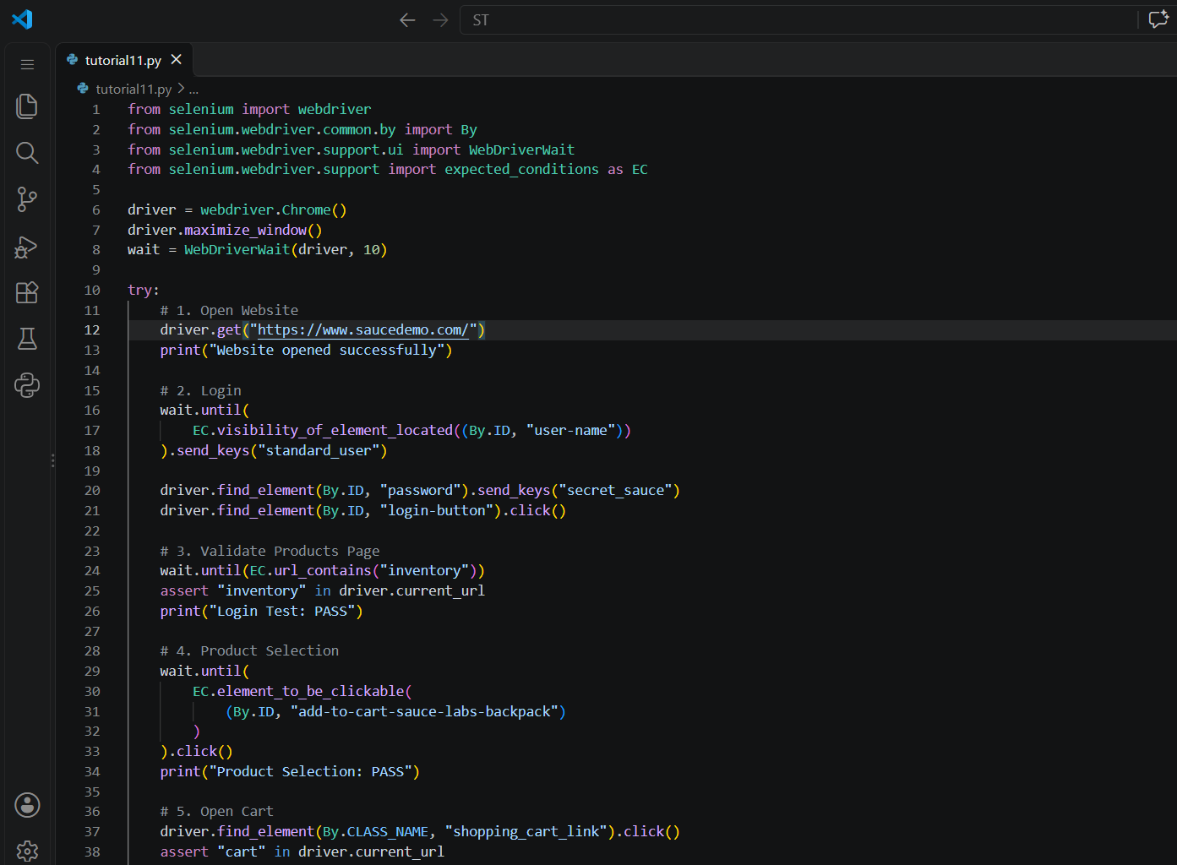
Figure 6: tutorial11.py (part 1)
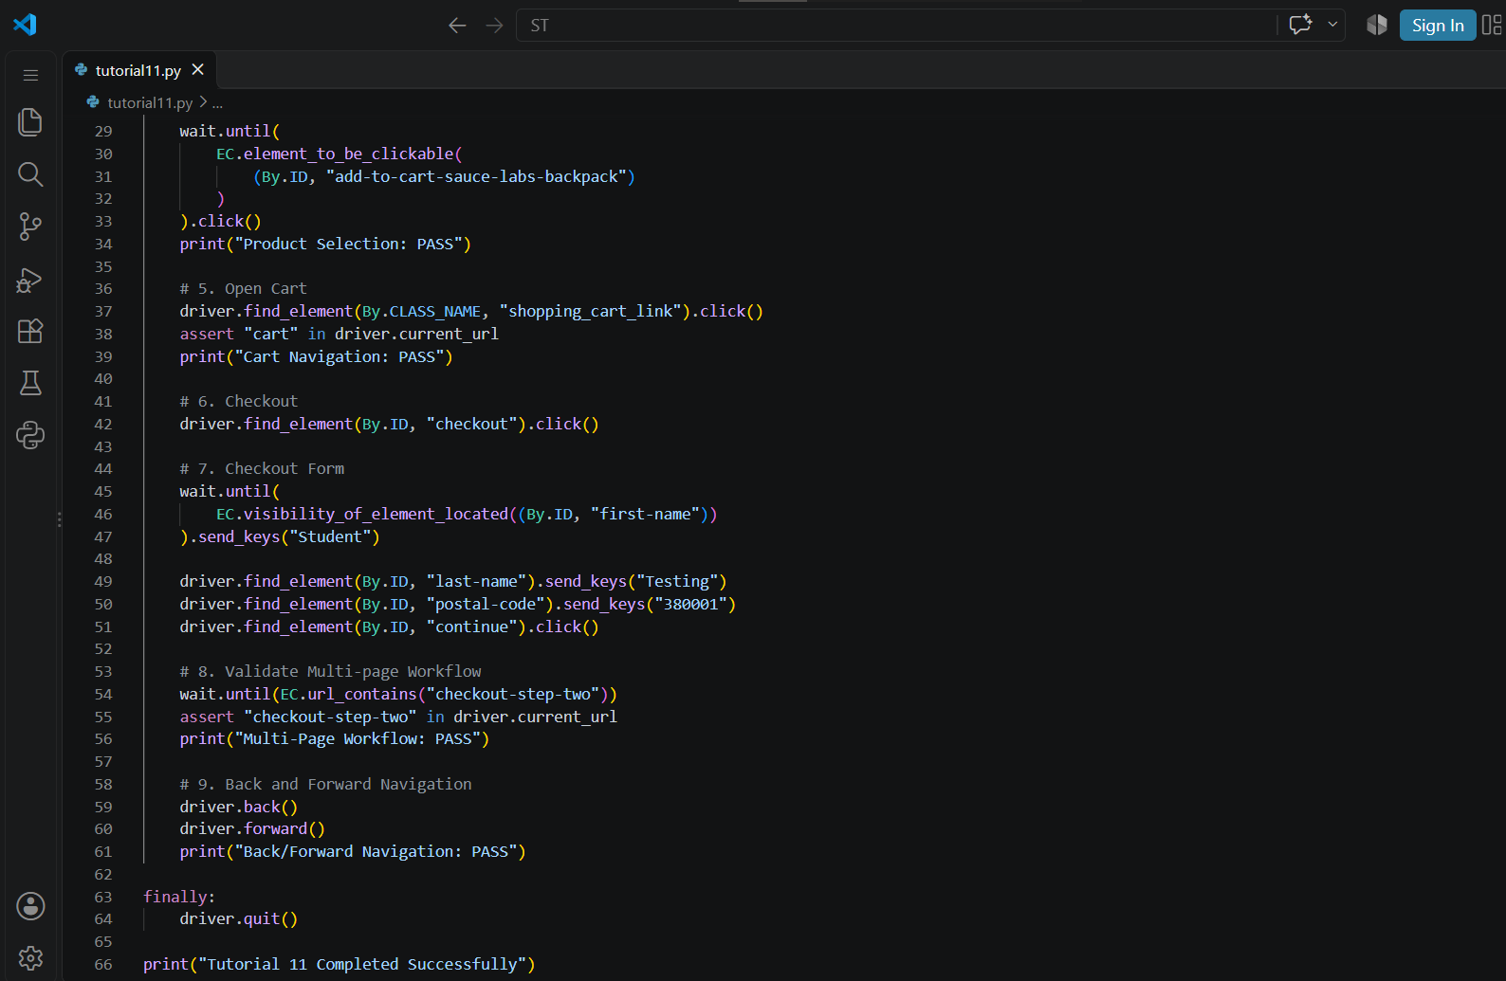
Figure 7: tutorial11.py (part 2)

Console Output
